Shrinkage correlation: NZDUSD and USDCAD
Method 08 / eight-major panel / delta = 0.2 and Ledoit-Wolf / Alpari D1 full available history

Study setup
Logical pair: NZDUSD , USDCAD
Broker symbols: NZDUSD_i , USDCAD_i
Snapshot: 2026-11-03_majors_alpari_D1
Timeframe: D1
Common eight-major panel window: 1999-01-06 to 2026-11-02 (UTC bar dates)
Panel matched return count n: 7127
Dropped unfinished last bar dated 2026-11-03 UTC after a tick-volume check against the prior complete day.
Fixed shrinkage: delta=0.2, mu=3.9170889e-05 (mean of diag(S))
Ledoit-Wolf estimated delta: 0.0042157642
Panel symbols: EURUSD, GBPUSD, AUDUSD, NZDUSD, USDJPY, USDCHF, USDCAD, EURGBP
Complete matched rows (Excel): NZDUSD-USDCAD_Shrinkage_D1.xlsx
Complete matched rows (HTML table): NZDUSD-USDCAD_Shrinkage_D1_data.html

Method carried forward
Shrinkage blends the sample covariance matrix S of matched daily log returns of close, ln(close_t / close_t-1), toward a simple target, then converts the shrunk covariance into correlations. Quotes are not inverted. This experiment builds one common calendar across all eight majors, forms S with the unbiased n-1 divisor, then reports two shrinkage specs: fixed delta = 0.2 with mu equal to the average sample variance (mu * I target), and sklearn Ledoit-Wolf with its estimated delta. Pair reports pull rho_ij from those panel matrices. Same-panel Pearson r is a side check only. Shrinkage improves conditioning; it is not a cause, not a lead, and not a trading signal.

Results
pearson_r | rho_02 | rho_LW | rho_02_minus_r | rho_LW_minus_r | delta_LW
-0.589889 | -0.466501 | -0.58722 | 0.123388 | 0.002669 | 0.00421576

Conclusion
Over the common 7127-day eight-major panel for NZDUSD and USDCAD (broker quote directions unchanged), fixed-delta shrinkage correlation at delta=0.2 is -0.4665 (negative, moderate linear link in this sample). Ledoit-Wolf rho is -0.5872 with estimated delta=0.004216. Same-panel Pearson r is -0.5899 (rho_02 minus r = 0.1234; rho_LW minus r = 0.0027). This does not establish cause, lead-lag, or a lasting trading rule.

Charts
Daily closes
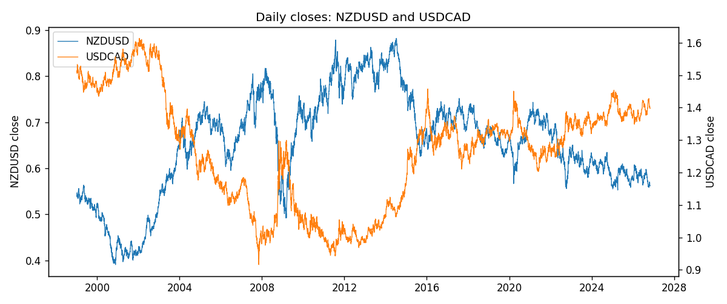
Daily log returns
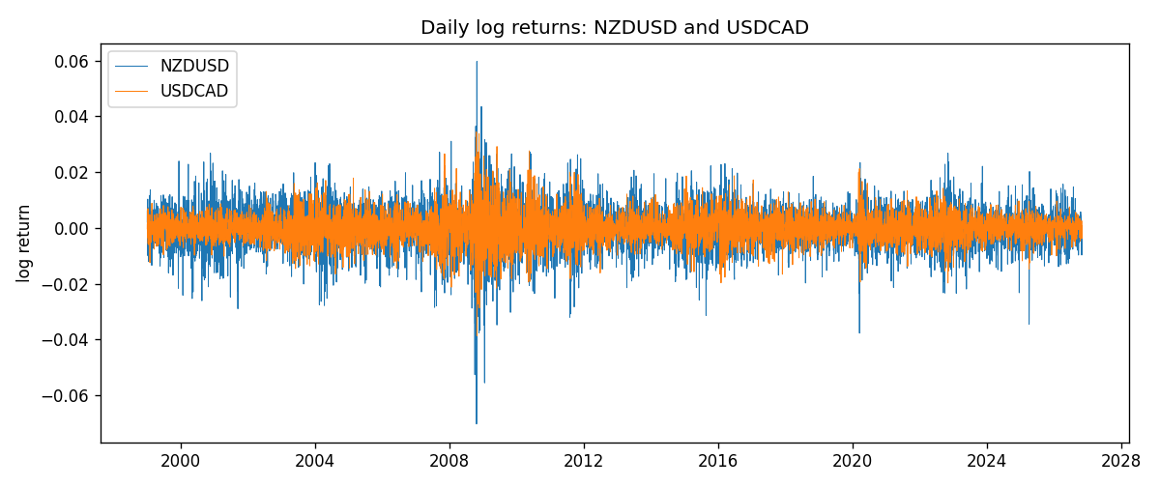
Log-return scatter
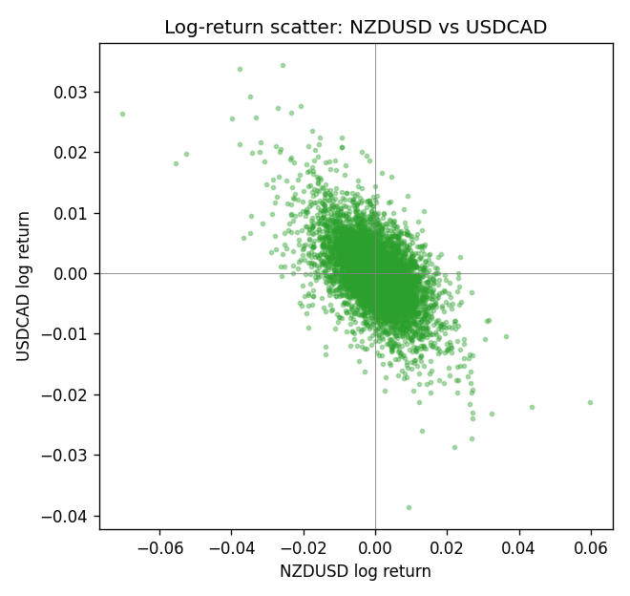

Data report
Every panel row for this pair slice is stored in the sibling Excel workbook named NZDUSD-USDCAD_Shrinkage_D1.xlsx. Full-panel covariance and correlation matrices are saved once under outputs/ as CSV files. Embedding all rows as a Word table is impractical at this length; the Word file holds the column list, column summaries, and the first and last 15 matched rows.
Columns: time, NZDUSD_open, NZDUSD_high, NZDUSD_low, NZDUSD_close, NZDUSD_tick_volume, NZDUSD_spread, NZDUSD_real_volume, NZDUSD_log_return, USDCAD_open, USDCAD_high, USDCAD_low, USDCAD_close, USDCAD_tick_volume, USDCAD_spread, USDCAD_real_volume, USDCAD_log_return
Column summaries (panel rows)
column | count | mean | std | min | 25% | 50% | 75% | max
NZDUSD_open | 7127 | 0.65707489 | 0.10792246 | 0.3913 | 0.59224 | 0.66889 | 0.725215 | 0.88218
NZDUSD_high | 7127 | 0.66100044 | 0.10841069 | 0.3961 | 0.595625 | 0.6726 | 0.72964 | 0.88421
NZDUSD_low | 7127 | 0.65338952 | 0.10751648 | 0.3897 | 0.588615 | 0.6651 | 0.721335 | 0.87988
NZDUSD_close | 7127 | 0.65715675 | 0.10791625 | 0.3907 | 0.5923 | 0.66906 | 0.725335 | 0.8822
NZDUSD_tick_volume | 7127 | 69244.396 | 123501.01 | 17 | 5842 | 34224 | 58735 | 1127682
NZDUSD_spread | 7127 | 30.023572 | 25.540824 | 0 | 9 | 17 | 40 | 80
NZDUSD_real_volume | 7127 | 1.6834718e+10 | 8.5315436e+10 | 0 | 0 | 0 | 0 | 2.705649e+12
NZDUSD_log_return | 7127 | 2.447e-05 | 0.00764665 | -0.07027433 | -0.00423198 | 0.00024001 | 0.00459119 | 0.05966839
USDCAD_open | 7127 | 1.2660158 | 0.16869092 | 0.9168 | 1.11698 | 1.29814 | 1.371685 | 1.6183
USDCAD_high | 7127 | 1.2709144 | 0.16864061 | 0.9336 | 1.122275 | 1.30368 | 1.37575 | 1.619
USDCAD_low | 7127 | 1.2614634 | 0.1687284 | 0.9056 | 1.112315 | 1.29315 | 1.36729 | 1.6102
USDCAD_close | 7127 | 1.2660395 | 0.16866578 | 0.916 | 1.116855 | 1.298 | 1.371955 | 1.6137
USDCAD_tick_volume | 7127 | 81672.889 | 147760.33 | 56 | 5669.5 | 41299 | 71973 | 1410818
USDCAD_spread | 7127 | 23.249895 | 18.19595 | 0 | 9 | 17 | 40 | 60
USDCAD_real_volume | 7127 | 1.8530805e+10 | 9.7086285e+10 | 0 | 0 | 0 | 0 | 2.5751613e+12
USDCAD_log_return | 7127 | -7.67e-06 | 0.00514753 | -0.03859748 | -0.0028338 | 5.597e-05 | 0.00272861 | 0.03436319
First 15 panel rows (selected columns)
time | NZDUSD_close | USDCAD_close | NZDUSD_log_return | USDCAD_log_return
1999-01-06 | 0.5383 | 1.5118 | 0.0020455609 | -0.0003306769
1999-01-07 | 0.5417 | 1.5141 | 0.0062963171 | 0.0015202092
1999-01-08 | 0.5414 | 1.511 | -0.00055396548 | -0.0020495197
1999-01-11 | 0.547 | 1.5057 | 0.010290425 | -0.0035137769
1999-01-12 | 0.5441 | 1.5157 | -0.0053157489 | 0.0066194721
1999-01-13 | 0.5387 | 1.5226 | -0.0099742238 | 0.0045420214
1999-01-14 | 0.5386 | 1.5332 | -0.00018564931 | 0.0069376546
1999-01-15 | 0.5382 | 1.5245 | -0.00074294208 | -0.0056905671
1999-01-18 | 0.5372 | 1.526 | -0.0018597736 | 0.00098344542
1999-01-19 | 0.5382 | 1.5302 | 0.0018597736 | 0.002748513
1999-01-20 | 0.5404 | 1.5211 | 0.0040793678 | -0.0059646885
1999-01-21 | 0.5426 | 1.5146 | 0.0040627941 | -0.0042823796
1999-01-22 | 0.5361 | 1.5184 | -0.012051689 | 0.0025057712
1999-01-25 | 0.5342 | 1.5197 | -0.0035504102 | 0.00085579808
1999-01-26 | 0.5381 | 1.52 | 0.0072741158 | 0.0001973879
Last 15 panel rows (selected columns)
time | NZDUSD_close | USDCAD_close | NZDUSD_log_return | USDCAD_log_return
2026-10-13 | 0.56127 | 1.4214 | 0.0047326165 | -0.0046395653
2026-10-14 | 0.55918 | 1.42356 | -0.0037306483 | 0.0015184751
2026-10-15 | 0.56185 | 1.41843 | 0.0047634855 | -0.0036101503
2026-10-16 | 0.56509 | 1.41357 | 0.0057501001 | -0.0034322068
2026-10-19 | 0.56616 | 1.41091 | 0.0018917133 | -0.0018835331
2026-10-20 | 0.56827 | 1.40569 | 0.0037199341 | -0.0037066008
2026-10-21 | 0.57003 | 1.4045 | 0.0030923331 | -0.00084691787
2026-10-22 | 0.56815 | 1.40081 | -0.0033035227 | -0.0026307268
2026-10-23 | 0.56991 | 1.40085 | 0.0030929853 | 2.85545e-05
2026-10-26 | 0.56826 | 1.40093 | -0.0028993932 | 5.7106554e-05
2026-10-27 | 0.56811 | 1.40449 | -0.00026399852 | 0.0025379458
2026-10-28 | 0.56261 | 1.39911 | -0.0097283914 | -0.0038379274
2026-10-29 | 0.56296 | 1.39895 | 0.00062190714 | -0.00011436495
2026-10-30 | 0.56307 | 1.39751 | 0.00019537668 | -0.0010298736
2026-11-02 | 0.56161 | 1.39837 | -0.0025962955 | 0.00061519094

